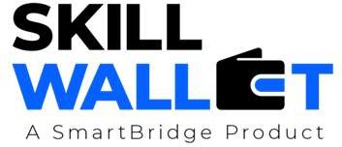

OptiCrop – AI Based Crop Recommendation System

Project Demo Planning

Project Demo Planning:
A well-structured demo plan ensures that the team presents the project effectively, covering all key aspects in a clear and organized manner. This document outlines the plan for demonstrating the project, including the flow of the demo, key features to highlight, and responsibilities of each team member.

S.No | Demo Section | Description | Duration (mins) | Responsible Member
1 | Introduction | Introduce the team, project objectives, and the agricultural problem addressed by OptiCrop. | 2 | Team Leader
2 | Problem Statement & Solution | Explain the need for AI-based crop recommendation and present the OptiCrop solution. | 2 | Member 1
3 | Live Application Demo | Demonstrate user login, crop prediction, fertilizer recommendation, and weather  information. | 5 | Member 2
4 | Technical Architecture | Explain the system architecture, machine learning model, Flask backend, and MySQL  database. | 3 | Member 3
5 | Results & Future Enhancements | Show prediction results, project benefits, and discuss future improvements. | 2 | Member 4
6 | Conclusion & Q&A | Summarize the project and answer questions from the evaluation panel | 1 | Entire Team

Demo Flow Summary:
Step | Activity | Notes
1 | Introduction & Problem Statement | Explain the challenges faced by farmers and the objective of the OptiCrop project.
2 | Solution Overview | Describe the system architecture, technologies used, and key modules of the application.
3 | Live Feature Demonstration | Demonstrate login, crop recommendation, fertilizer recommendation, weather information, and prediction results.
4 | Q&A Session | Answer questions related to implementation, machine learning model, and future enhancements.

